

Tribhuvan University
Faculty of Humanities and Social Science
An Internship Report
On
UI/UX of aimid
At
Treeleaf Technologies Pvt. Ltd.
Sankhamul, Lalitpur, Nepal
In partial fulfillment of requirements in Bachelor’s in computer applications
Submitted by:
Piyush Sthapit (41002140)
August 2026 A.D.
Under the Supervision of
Ms. Rolisha Sthapit

Tribhuvan University
Faculty of Humanities and Social Science
An Internship Report
On
UI/UX of aimid
At
Treeleaf Technologies Pvt. Ltd.
Sankhamul, Lalitpur, Nepal
In partial fulfillment of requirements in Bachelor’s in computer applications
Submitted by:
Piyush Sthapit (41002140)
August 2026 A.D.
Under the Supervision of
Ms. Rolisha Sthapit

MENTORS RECOMMENDATION

Tribhuvan University
Faculty of Humanities and Social Science
SUPERVISOR'S RECOMMENDATION
It is my pleasure to recommend that an internship report on User Interface (UI)/User Experience (UX) has been prepared under my supervision by Piyush Sthapit in partial fulfillment of the requirement of the degree of Bachelor of Computer Applications. His report is satisfactory and is original work done by him to proceed for the future evaluation.
Ms. Rolisha Sthapit
SUPERVISOR
Prime College
Tribhuvan University
Faculty of Humanities and Social Science
LETTER OF APPROVAL
Ms. Rolisha Sthapit  Supervisor  Prime College  Khusibu, Nayabajar, Kathmandu | Ms. Rolisha Sthapit  Vice Principle, Department of IT BCA Department  Prime College  Khusibu, Nayabajar, Kathmandu
 | External Examiner
This is to certify that this internship report prepared by Piyush Sthapit on “UI/UX Design Internship at Treeleaf Technologies” in partial fulfillment of the requirements for the degree of Bachelor's in Computer Application has been evaluated. In our opinion it is satisfactory in terms of scope and quality as a project for the required degree.

ACKNOWLEDGEMENT
The intern would like to express sincere gratitude to everyone who contributed to the successful completion of the internship and the preparation of this report. First and foremost, heartfelt appreciation is extended to Treeleaf Technologies for providing the opportunity to be part of a dynamic and professional working environment.
The intern is deeply grateful to the mentor, Mr. Prabhat Chandra Joshi, Admin Assistant, whose guidance, support, and encouragement were instrumental throughout the internship period. His continuous support and practical guidance played a crucial role in enhancing the intern's professional skills and overall learning experience.
Special appreciation is also extended to Ms. Rolisha Sthapit for her invaluable support as Supervisor. Her guidance, coordination, and constructive feedback ensured the smooth progress and successful completion of the internship and this report.
The intern would also like to thank all team members and colleagues at Treeleaf Technologies for their cooperation, collaboration, and willingness to share knowledge. This internship has been a truly transformative experience, and the intern is sincerely thankful to everyone who contributed to making it both educational and rewarding.
Piyush Sthapit

ABSTRACT
This internship report reflects my learning experience at Treeleaf Technologies, where the intern worked as a UI/UX Design Intern on the aimid AI middleware and governance platform, the Identeq single sign-on and identity platform, and the TreeKall AI-powered omnichannel communication platform. The internship focused on creating clear, consistent, and visually engaging interfaces and marketing collateral to communicate complex AI products to a wide range of audiences. During the internship, The intern worked on building multi-slide product presentations, designing HTML landing pages, creating social media assets, and developing interactive prototypes in Figma. This experience helped the intern apply design principles in a practical way while strengthening the intern’s problem-solving, creativity, and collaborative skills, working directly under the guidance of my supervisor and receiving iterative feedback on each deliverable. The report outlines the objectives, scope, and challenges faced during the design process, and includes an overview of Treeleaf Technologies and the supportive environment that contributed to the intern’s learning. Overall, this internship was a valuable experience that enhanced the intern’s UI/UX skills and gave the intern the confidence to work on real-world design projects.
Keywords: UI/UX Design, Artificial Intelligence, Middleware, Identity Management, Figma, Prototyping, Presentation Design

TABLE OF CONTENTS
MENTORS RECOMMENDATION iii
SUPERVISOR'S RECOMMENDATION iv
LETTER OF APPROVAL v
ACKNOWLEDGEMENT vi
ABSTRACT vii
LIST OF ABBREVIATIONS ix
LIST OF FIGURES x
LIST OF TABLES xi
CHAPTER 1: INTRODUCTION
1.1 Introduction 1
1.2 Problem Statement 2
1.3 Objectives 2
1.4 Scope and Limitations 2
1.5 Report Organization 3
CHAPTER 2: INTRODUCTION TO ORGANIZATION
2.1 Organization Details 4
2.2 Organizational Hierarchy 5
2.3 Working Domains of Organization 6
2.4 Description of Intern Department 7
CHAPTER 3: BACKGROUND STUDY AND LITERATURE REVIEW
3.1 Background Study 9
3.2 Literature Review 10
CHAPTER 4: INTERNSHIP ACTIVITIES
4.1 Roles and Responsibilities 12
4.2 Weekly Log 13
4.3 Description of Projects Involved During Internship 16
4.4 Tasks / Activities Performed 18
CHAPTER 5: CONCLUSION AND LEARNING OUTCOMES
5.1 Conclusion 26
5.2 Learning Outcome 26
REFERENCES 28
APPENDICES

LIST OF ABBREVIATIONS
AI Artificial Intelligence
API Application Programming Interface
IAM Identity and Access Management
PPTX PowerPoint Presentation File Format
SSO Single Sign-On
UI/UX User Interface and User Experience

LIST OF FIGURES
Figure 2.1 Organizational Hierarchy 5
Figure 2.2 Intern Department Hierarchy 7
Figure 4.1 aimid flowchart 17
Figure 4.2 Wireframe 18
Figure 4.3 Low Fidelity 19
Figure 4.4 High Fidelity 20
Figure 4.5 aimid Presentation Sample Slide 20
Figure 4.6 aimid Landing Page 21
Figure 4.7 Identeq Sample Slide 22
Figure 4.8 Instagram Post Asset (Canva/PPTX) 23
Figure 4.9 Dropdown Interaction 24
Figure 4.10 Prototyping 25

LIST OF TABLES
Table 2.1 Contact Details of the Organization 4
Table 2.2 Domains of the Organiztion 6
Table 2.3 Intership Duration Details 8
Table 4.1 Weekly Log 13
Table 4.2 Overview of Design Work Across Treeleaf Products 18
CHAPTER 1

INTRODUCTION

1.1 Introduction

aimid helps organizations monitor, manage, and govern their use of artificial intelligence systems, but as with most enterprise AI products, its capabilities are technical and multi-layered, making it difficult to communicate clearly to prospective clients, partners, and internal stakeholders who may not have a deep technical background.

As organizations adopt more AI tools across their teams, they often struggle to explain, even internally, what a governance and middleware layer actually does for them. This gap between aimid's technical capability and audience understanding was the central design challenge behind this project: translating aimid's abstract, infrastructure-level functionality into something a business owner, a non-technical stakeholder, or a first-time visitor to the website could grasp within seconds.

The project involved designing the complete visual identity and communication material for aimid, including a multi-slide product presentation covering pricing, features, industry context, and use cases; a full HTML landing page with light and dark theme support and dropdown navigation; a dedicated Products & Solutions page; a native website design file in Figma; and the aimid logo itself, using gradient text treatment and a circuit/connector motif to visually reflect the product's AI and connectivity focus. Each of these deliverables addressed a different point of contact with aimid's audience, the presentation for sales and pitch contexts, the landing page and Products & Solutions page for self-serve web discovery, and the logo as the consistent visual anchor tying all of it together.

The design process followed a user-centered, iterative approach, with each aimid deliverable reviewed and refined based on direct feedback from the supervisor. The primary focus throughout was on visual clarity, brand consistency, and usability, ensuring that aimid's complex, technical value proposition could be understood quickly and confidently by a non-technical audience, while also giving the development team a clear, well-structured reference for implementation.

Working on aimid end-to-end, from presentation slides through to the live landing page and logo, provided an in-depth, practical opportunity to apply UI/UX design principles across multiple formats and touchpoints, and to see first-hand how design decisions made at the concept stage carry through to a finished, client-facing product.

1.2 Problem Statement

aimid is a technically sophisticated AI governance and middleware platform, but without clear, well-designed visual materials, it is difficult for clients and stakeholders to understand its features, pricing, and use cases. This challenge is compounded by a deeper, underlying problem: without a centralized governance layer, organizations struggle to enforce consistent policies, track AI usage, and ensure compliance as they connect multiple AI models and tools across different teams and systems.

1.3 Objectives
- To give organizations centralized visibility into how AI models and systems are being used across their teams, tools, and workflows.
- To act as a middleware layer that allows organizations to safely and efficiently integrate and orchestrate multiple AI models and systems from a single point of control.

1.4 Scope and Limitations

1.4.1 Scope
- It is designed to work across an organization's existing AI tools and models, rather than being tied to any single AI provider or system.
- aimid is aimed at organizations of varying sizes that are adopting or scaling AI usage and need a structured way to track, control, and remain accountable for that usage.

1.4.2 Limitations
- aimid does not build, train, or host AI models itself it governs and connects AI systems that already exist, rather than replacing them.
- aimid focuses on organizational-level AI governance and does not extend into unrelated areas such as general IT infrastructure management or non-AI software governance.

1.5 Report Organization
The first chapter introduces the internship project, outlining the design work carried out at Treeleaf Technologies. It sets the stage by explaining the significance of the project, its objectives, and the challenges addressed during the internship, giving readers a clear understanding of the purpose and context of the work.
Chapter 2 presents detailed information about Treeleaf Technologies, including its organizational structure, hierarchy, and working domains. This chapter also highlights the specific department where the internship was conducted, offering insights into the environment in which the project was executed.
Chapter 3 establishes the theoretical foundation for the project. It discusses relevant UI/UX design concepts, tools, and terminologies, and includes a literature review providing an overview of best practices that informed the design work.
Chapter 4 provides a detailed account of the intern's roles and responsibilities. It includes a weekly log of activities and a chronological description of tasks performed, along with the specific projects the intern contributed to.
The final chapter summarizes the key findings and outcomes of the internship, presents the overall conclusions, highlights the learning outcomes, and reflects on the personal and professional growth achieved during the internship.
CHAPTER 2

INTRODUCTION TO ORGANIZATION

2.1 Organization Details
Treeleaf Technologies is an AI-focused technology company based in Sankhamul, Lalitpur, Nepal, that designs and builds AI-driven software platforms for businesses. The organization provides expertise across multiple domains, including AI middleware and governance, identity and access management, and AI-powered omnichannel communication. By combining technical proficiency with strong product design, Treeleaf Technologies helps organizations adopt AI responsibly while improving operational efficiency.
The company's product portfolio includes aimid, an AI middleware and governance platform that helps organizations monitor, manage, and govern their use of artificial intelligence systems; Identeq, a single sign-on and identity platform that secures and simplifies user authentication across applications; and TreeKall, an AI-powered omnichannel communication platform that unifies customer interactions across multiple channels.
Treeleaf Technologies places strong emphasis on innovation, clear communication, and design quality, ensuring that its products are not only technically capable but also accessible and easy to understand for the businesses that use them.

2.1.1 Contact Details of the Organization

The following is the contact details of the organization:

Table 2.1: Contact Details of the Organization
Official Name | Treeleaf Technologies Pvt. Ltd
Location | Sankhamul-11, Lalitpur, Nepal
Email Address | info@treeleaf.ai
Website | https://treeleaf.ai/
Office Hours | 9:00am – 6:00pm
Establishment Year | 2017 A.D

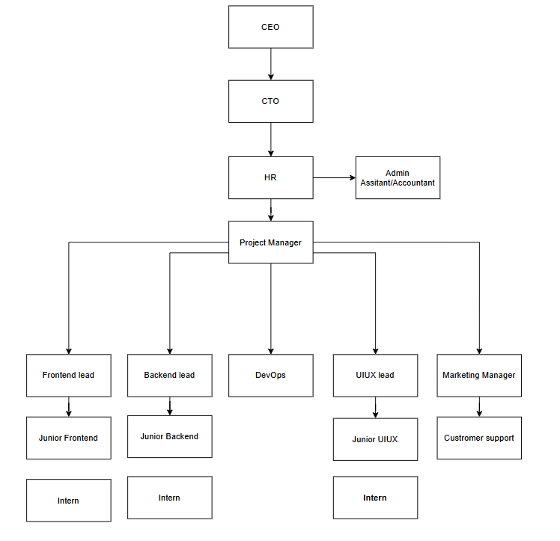
2.2 Organizational Hierarchy
Figure 2.1: Organizational Hierarchy
Treeleaf Technologies is organized to efficiently manage and deliver its AI-driven products. Leadership defines the company's long-term vision and product strategy, while product and design leads oversee the direction of individual platforms such as aimid, Identeq, and TreeKall.
The design team, which the intern was part of, works closely with the development team to translate product concepts into clear, well-designed visual assets including presentations, landing pages, social media content, and interactive prototypes that support both external communication and internal development handoff. All design deliverables were reviewed by a supervisor (boss) before being finalized.
2.3 Working Domains of Organization
Treeleaf Technologies operates in the Information Technology (IT) domain, specializing in AI-driven software platforms and enterprise solutions. The company supports clients by delivering reliable, user-centric, and scalable software systems built around artificial intelligence.
Primary Areas of Focus:
- AI middleware and governance: enabling organizations to manage and monitor their AI systems responsibly through the aimid platform.
- Identity and access management: securing user authentication and access through the Identeq platform.
- Omnichannel communication: unifying customer interactions across channels through the TreeKall platform.
Product Portfolio:
- aimid – AI middleware and governance platform
- Identeq – Single sign-on and identity platform
- TreeKall – AI-powered omnichannel communication platform

Table 2.1: Domains of the Organization

Aspect | Details
Product Type | AI models management system
Functionality | Sits between AI applications and models/APIs and enforces rate limiting, IP whitelisting, two-layer guardrails, real-time monitoring, model routing, and REST-to-MCP conversion for agentic AI
Adaptability | Available only as a web application.
User Accessibility | Accessible through standard web browsers.

2.4 Description of Intern Department
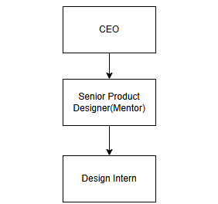

Figure 2.2: Intern Department Hierarchy
Within the organizational structure of Treeleaf Technologies, the UI/UX Design Intern reports directly to a supervisor (boss) who reviews and provides direction on all deliverables. Under this reporting framework, the intern supports ongoing product marketing and design initiatives across aimid, Identeq, and TreeKall, ensuring that all deliverables align with brand standards and project goals.
In this role, the intern works on a range of design tasks including building multi-slide product presentations covering pricing, features, industry use cases, and product overviews; designing HTML landing pages with light and dark themes and dropdown navigation; creating Instagram post assets as editable PowerPoint files for import into Canva; and building interactive prototypes in Figma, including hover-triggered dropdowns, overlay interactions, and component variants.
This internship provides a valuable opportunity to apply academic knowledge in a professional environment, strengthen both creative and analytical skills, and gain hands-on experience in UI/UX and presentation design within a fast-moving AI company.
2.4.1 Internship Period Details
According to the requirements of the BCA program at Tribhuvan University, the intern successfully completed a 3-month internship from May 15th, 2026 to August 17th, 2026
Table 2.2 : Internship Duration Details
Start Date | May 15th,2026
End Date | August 17th,2026
Duration | 3 months
Working Days | Monday to Friday
Office Hours | 9:00 am – 6:00pm
Position | UI/UX Intern
Mentor | Prabhat Chandra Joshi

CHAPTER 3

BACKGROUND STUDY AND LITERATURE REVIEW

3.1 Background Study
In the modern era, organizations across industries are increasingly dependent on artificial intelligence to streamline operations, manage data, and deliver services efficiently. As AI adoption grows, companies face the challenge of communicating complex, technical AI products in ways that are clear and accessible to non-technical audiences, while also ensuring that the interfaces built around these products are usable, secure, and consistent.
Treeleaf Technologies operates in this dynamic technological landscape by providing AI-driven platforms, including aimid, Identeq, and TreeKall. Successfully bringing these products to market requires a strong design foundation: clear presentations, consistent branding, accessible landing pages, and well-designed interactive prototypes that both explain the product to clients and guide developers during implementation.
The UI/UX design process is a key component of building successful software products. Intuitive and visually consistent design reduces confusion, improves comprehension, and enhances audience engagement. Principles such as visual hierarchy, consistency, and accessibility are critical to ensuring that presentations, web pages, and prototypes can be effectively understood by a diverse range of audiences, from technical stakeholders to prospective business clients. Tools such as Figma, Canva, and PowerPoint are widely used to create wireframes, branded presentations, and interactive prototypes that guide both communication and development.
The internship at Treeleaf Technologies provided an opportunity to apply UI/UX design principles across multiple product lines simultaneously, offering hands-on experience in a real-world, fast-paced software company environment. Responsibilities included designing presentations, building landing pages, creating social media assets, and developing interactive prototypes, all shaped through iterative feedback from a supervisor.
Overall, this background underscores the significance of combining design consistency, iterative feedback, and cross-platform thinking in modern AI product marketing and design.

3.2 Literature Review

The increasing adoption of AI technologies across industries has created a growing demand for clear, user-friendly ways of communicating what these technologies do. User experience (UX) and interface design (UI) have emerged as critical factors that directly impact how well a product is understood and adopted (Norman, 2013). Well-designed presentations and interfaces reduce confusion, streamline communication, and enable faster understanding of complex features, particularly for AI and enterprise software products.

UI/UX design principles emphasize the importance of understanding audience needs, visual hierarchy, and consistency across touchpoints (Garrett, 2011). Kim et al. (2022) argue that user-centered design should anchor product and communication decisions in customer value from the outset, rather than being treated as a finishing step applied after a product's technical direction has already been set. This view is particularly relevant to enterprise AI products such as aimid, where the underlying technology is often decided well before its value is communicated to a non-technical audience, making early, user-centered design input essential rather than optional.

Research indicates that intuitive navigation, visual consistency, and responsive layouts significantly improve comprehension and reduce cognitive load for end-users. Muhyidin, Sulhan, and Sevtiana (2020) demonstrate this in a study on interface design for an academic information service, where structuring the design process around Figma-based prototyping allowed the design team to test navigation and layout decisions with users before development, resulting in a more intuitive final interface. Tools such as Figma and Canva are widely employed to create wireframes, prototypes, and branded visual assets, enabling designers to iterate quickly and validate design decisions before finalizing deliverables, a workflow that closely mirrors the presentation, landing page, and prototype work carried out for aimid during this internship.

Several studies also highlight the value of iterative design processes, where continuous feedback from stakeholders drives improvements in visual communication and interface design (Saffer, 2010). Cajander, Larusdottir, and Geiser (2022) similarly find that UX professionals working in agile, fast-paced environments rely heavily on lightweight, repeatable methods quick prototypes, informal reviews, and short feedback loops rather than lengthy, formal design processes, since project direction and priorities can shift quickly. This is particularly relevant to design work at fast-moving technology companies such as Treeleaf Technologies, where marketing and product materials must be revised quickly in response to direction from product leads and supervisors.

Beyond general UI/UX literature, the nature of aimid as an AI governance and middleware platform also draws on literature specific to AI governance communication. Mäntymäki, Ahokangas, and Oksanen (2022) define organizational AI governance as the set of structures, policies, and oversight mechanisms that allow organizations to manage AI systems responsibly, noting that these concepts are often abstract and difficult for non-specialist audiences to grasp without concrete, well-structured visual explanation. The National Institute of Standards and Technology (2023) reinforces this point in its AI Risk Management Framework, which stresses that governance and risk-management concepts must be communicated clearly to a broad range of organizational stakeholders, not just technical teams, if they are to be adopted effectively. Together, these sources suggest that visual communication design plays a direct role in making AI governance concepts such as those central to aimid accessible and actionable for the organizations that need to adopt them.

In conclusion, the literature indicates that combining user-centered design principles with iterative, feedback-driven workflows is critical for delivering effective visual communication for AI-driven products, and that this need is heightened for products like aimid that sit in the comparatively abstract space of AI governance and middleware. The internship at Treeleaf Technologies aligns with these findings by providing practical exposure to presentation design, landing page design, prototyping, and collaborative, feedback-based design cycles, applied directly to the challenge of making aimid's governance and middleware capabilities understandable to a broad, non-technical audience.

CHAPTER 4

INTERNSHIP ACTIVITIES

4.1 Roles and Responsibilities
During the internship at Treeleaf Technologies, the intern was assigned responsibilities spanning presentation design, web page design, social media asset creation, and interactive prototyping, providing hands-on exposure to real-world product design and marketing practices. The roles were designed to ensure active contribution to multiple product lines while fostering learning and skill development.

Presentation Design:
The intern designed multi-slide PowerPoint presentations for aimid, Identeq, and TreeKall, covering pricing, product features, industry context, and use cases, ensuring visual consistency and clarity while incorporating feedback from the supervisor.

Landing Page Design:
The intern built a full HTML landing page for aimid, including light and dark theme support, dropdown navigation, and a dedicated Products & Solutions page.

Social Media Asset Creation:
The intern developed Instagram post assets as editable PPTX files for import into Canva, iterating on layouts including quote posts, feature grids, and flow diagrams based on feedback.

Prototyping and Figma Work:
The intern built interactive prototypes and design components in Figma, including hover-triggered dropdowns, overlay interactions, and component variants, and worked on a native website design file for aimid.

Branding:
The intern contributed to the aimid logo design, applying gradients to text and incorporating a circuit/connector motif, and worked on branding and social media posts for TreeKall as well as a client logo project for Automiq.

4.2 Weekly Log
The following table shows the weekly activities performed by the intern throughout the internship period, from 15th May 2026 to 17th August 2026.

Table 4.1: Weekly Log
Week | Activities
Week 1  15 May – 19 May | - Completed onboarding at Treeleaf Technologies and was introduced to the company's culture, workflow, and reporting structure.  - Received an overview of the company's core products aimid, Identeq, and TreeKall and their target audiences.  - Set up and configured design tools including Figma, Canva, and PowerPoint for project work.  - Reviewed existing brand assets, style guides, and prior design materials to understand Treeleaf's visual identity.
Week 2  22 May – 27 May | - Designed Instagram post assets as editable PPTX files for import into Canva.  - Created quote-post layouts highlighting key product messaging in a visually engaging format.  - Built feature-grid post layouts to showcase multiple product highlights in a single design.  - Ensured all post templates followed Treeleaf's brand colors, fonts, and visual style for consistency
Week 3  29 May – 2 Jun | - Began designing the TreeKall 14-slide presentation, structuring the overall flow and slide sequence.  - Designed slides covering TreeKall's core features and omnichannel communication capabilities.  - Developed an accompanying 2-page brochure summarizing TreeKall's value proposition.  - Coordinated slide and brochure layouts to maintain visual consistency across both formats.
Week 4  5 Jun – 9 Jun | - Revised the TreeKall brochure based on the boss's feedback.  - Removed bullet-heavy sections and restructured content into a more visual, scannable format.  - Added dedicated channel cards to visually represent TreeKall's communication channels.  - Rewrote brochure copy to improve clarity, tone, and overall messaging impact.
Week 5  12 Jun – 15 Jun | - Developed branding assets and social media post designs for TreeKall.  - Ensured social post designs aligned with the revised brochure's visual direction.  - Contributed to a client logo project for Automiq, exploring initial concepts and layouts.  - Iterated on logo design options based on discussions with the design lead.
Week 6  19 Jun – 23 Jun | - Began designing the Identeq 20-slide presentation from scratch.  - Established a branded slide template, including layout grid, typography, and color scheme.  - Designed initial slides introducing Identeq's single sign-on and identity management features.  - Planned the overall slide structure to logically walk through the platform's capabilities.
Week 7  26 Jun – 2 Jul | - Continued building out the remaining slides of the Identeq deck.  - Incorporated feedback from the supervisor to refine slide content and structure.  - Refined visual consistency across all 20 slides, including spacing, iconography, and color usage.  - Proofread and polished slide copy for clarity and professional tone.
Week 8  3 Jul – 6 Jul | - Began work on the aimid multi-slide PowerPoint presentation.  - Designed the pricing section, presenting plans and tiers in a clear, comparable format.  - Designed the product overview section, introducing aimid's core AI governance and middleware features.  - Established a slide template and visual style consistent with the aimid brand palette.
Week 9  9 Jul – 13 Jul | - Continued the aimid presentation, focusing on the industry and use case sections.  - Designed slides illustrating how aimid apply across different industry contexts.  - Incorporated the first round of revisions based on the boss's feedback.  - Adjusted slide content and visuals to better communicate aimid's value to a non-technical audience.
Week 10  15 Jul – 23 Jul | - Worked on the aimid native website design file in Figma.  - Structured key website sections, including layout, navigation, and content hierarchy.  - Developed the aimid logo, applying gradient treatment to the text.  - Incorporated a circuit/connector motif in Canva to visually reflect aimid's AI and connectivity focus.
Week 11  24 Jul – 30 Jul | - Started building the aimid landing page in HTML.  - Implemented dropdown navigation for smooth access to different page sections.  - Built light and dark themes support to give users a consistent experience in either mode.  - Aligned landing page visuals with the aimid brand palette and logo design.
Week 12  31 Jul – 5 Aug | - Carried out Figma prototyping work to support the aimid website and product interfaces.  - Built hover-triggered dropdown interactions for navigation elements.  - Designed overlay interactions to demonstrate key product flows.  - Created component variants to support consistent, reusable design elements.
Week 13  7 Aug – 11 Aug | - Completed the aimid landing page, finalizing all sections and content.  - Built a separate Products & Solutions page detailing aimid's specific offerings.  - Conducted cross-browser testing to ensure consistent rendering across platforms.  - Tested light and dark theme switching for visual consistency and usability.
Week 14  14 Aug – 17 Aug | - Conducted final reviews of all completed design work with the mentor and supervisor.  - Made last-round revisions based on final feedback.  - Documented completed design work, including file organization and design decisions.  - Prepared handoff notes for the development team to support implementation.

4.3 Description of Projects Involved During Internship
During the internship at Treeleaf Technologies, the intern was involved in design work across three primary AI products: aimid, Identeq, and TreeKall, each requiring a distinct set of visual communication materials tailored to its purpose and audience.
The aimid project, an AI middleware and governance platform, required the most extensive design work, including a multi-slide PowerPoint presentation covering pricing, product, industry, and use case sections; a full HTML landing page with light and dark theme support and dropdown navigation; a separate Products & Solutions page; and logo development involving gradient text treatment and a circuit/connector motif created in Canva.
The Identeq project, a single sign-on and identity platform, involved building a 20-slide presentation deck from scratch with fully branded styling, communicating the platform's authentication and access-management capabilities to prospective clients.
The TreeKall project, an AI-powered omnichannel communication platform, involved designing a 14-slide presentation deck and a 2-page brochure, which went through several boss-driven revisions removing bullet-heavy sections, adding channel cards, and rewriting copy for clarity as well as branding and social media post assets.
Throughout the internship, the intern worked closely with the supervisor (boss), who reviewed and provided direction on all deliverables, following an iterative, feedback-driven design workflow. This involvement provided practical exposure to designing across multiple product lines simultaneously, from initial concept to final, polished deliverable.
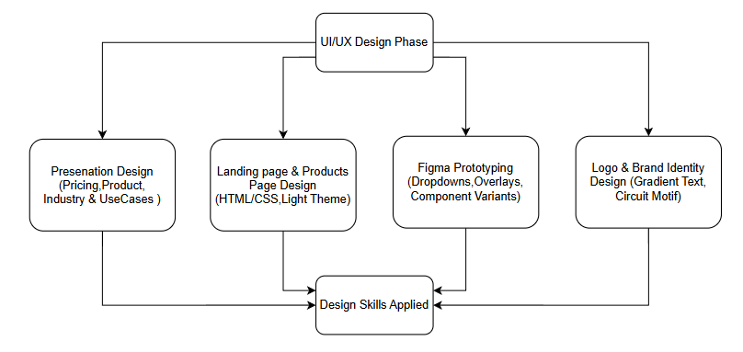
Figure 4.1: aimid flowchart

Aspect | aimid | Identeq | TreeKall
Product Type | AI middleware & governance platform | Single sign-on & identity platform | AI omnichannel communication platform
Key Deliverables | PPTX deck, HTML landing page, Products page, logo | 20-slide branded PPTX deck | PPTX deck, brochure, social posts
Core Tools | PowerPoint, HTML/CSS, Figma, Canva | PowerPoint | PowerPoint, Canva
Table 4.2: Overview of Design Work Across Treeleaf Products

4.4 Tasks / Activities Performed
As per the academic requirement of the BCA program, the intern worked as a UI/UX Design Intern at Treeleaf Technologies. The major activities the intern performed during the internship period are described below.
Wireframes: Initial wireframes were developed to define the overall layout and structural framework of the aimid landing page and presentation slides, guided by findings from stakeholder input and Treeleaf's existing brand direction. The wireframes focused on organizing content in a clear, logical, and user-friendly manner, ensuring that essential sections like pricing, product overview, and industry use cases were easily accessible. Special attention was given to establishing a strong visual hierarchy through proper spacing, alignment, and grouping of elements, allowing users to quickly understand and navigate the interface. The wireframes also served as a communication tool between the intern and the supervisor, helping to validate design concepts, identify usability concerns early, and guide the transition to high-fidelity designs.
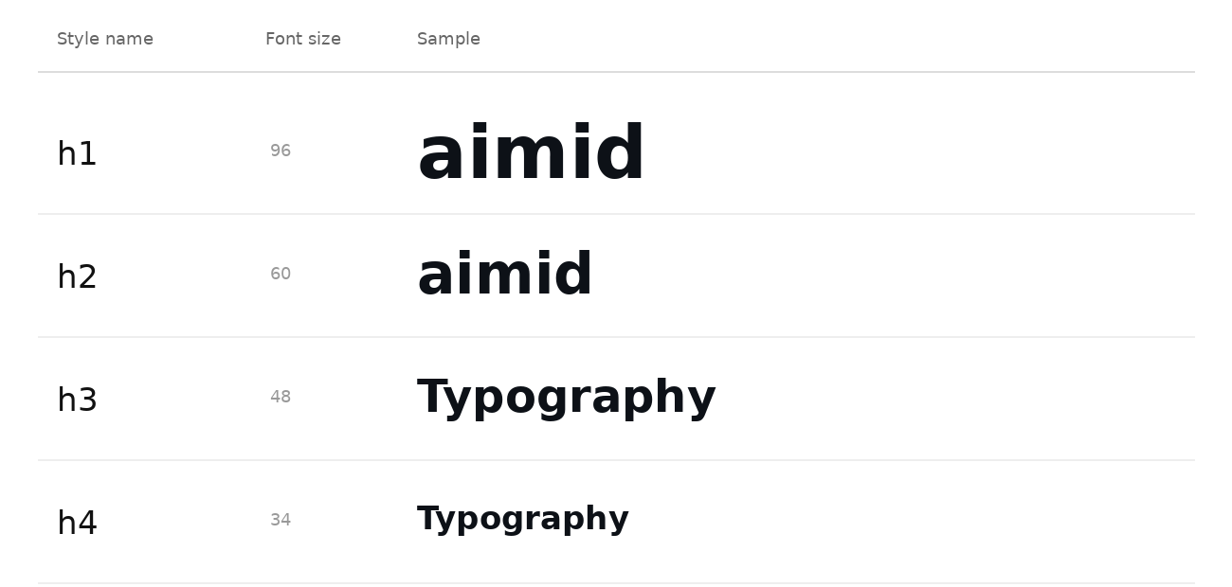

Figure 4.2: Wireframe

Fidelity: The fidelity of a prototype dictates its primary purpose in the design cycle. Low-fidelity prototypes are tools for problem-solving and conceptual validation. By stripping away aesthetics using sketch-like wireframes, grayscale layouts, and placeholder text, they force focus on usability, information architecture, and core workflows. This simplicity enabled rapid iteration and early critique from the supervisor on how the aimid landing page and presentation should work.
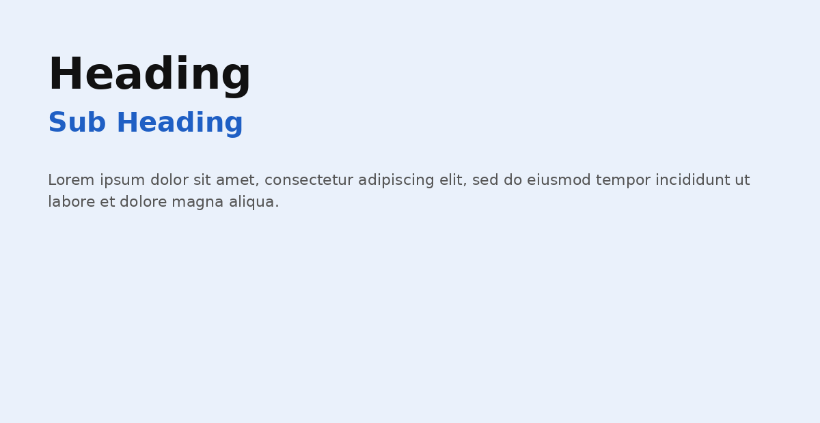

Figure 4.3: Low Fidelity
Conversely, high-fidelity prototypes are tools for experience validation and detailed communication. They simulate the final product with pixel-perfect visuals, the aimid brand palette (dark navy #0D1117, blue #1F5FC4/#2F81F6), real content, and nuanced interactions such as hover-triggered dropdowns. This realism was critical for testing the feel of the experience with stakeholders and providing the development team with a precise, unambiguous specification to guide implementation.
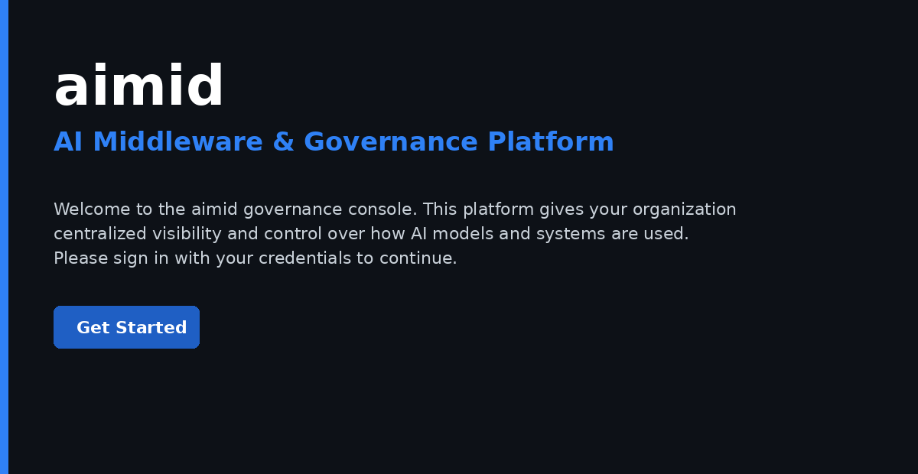

Figure 4.4: High Fidelity
aimid Presentation Deck: A multi-slide presentation was built for aimid using Canva, covering pricing, product, industry, and use case sections. The deck was designed to communicate the platform's AI governance and middleware capabilities clearly to both technical and non-technical audiences, with iterative revisions made based on direct feedback from the supervisor.

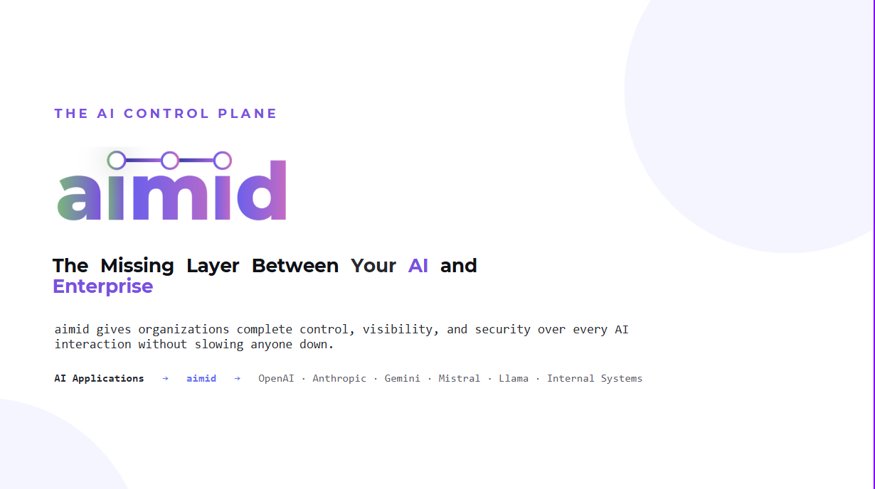
Figure 4.5: aimid Presentation Sample Slide

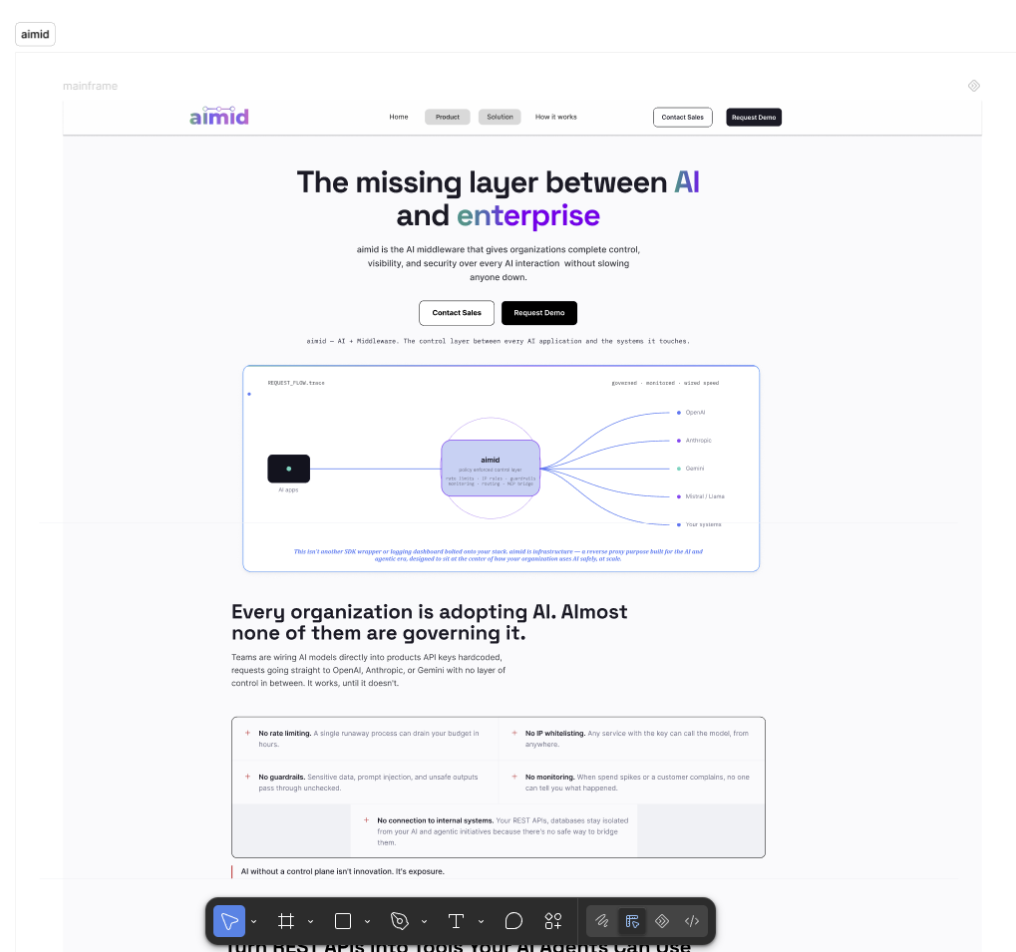
aimid Landing Page: A full HTML landing page was developed for aimid using HTML and CSS, featuring light and dark theme support, dropdown navigation, and a separate Products & Solutions page. The layout and visual structure were first planned in Figma before being built out in code. Special attention was given to visual hierarchy, responsive layout, and consistent branding across both theme modes.

Figure 4.6: aimid Landing Page

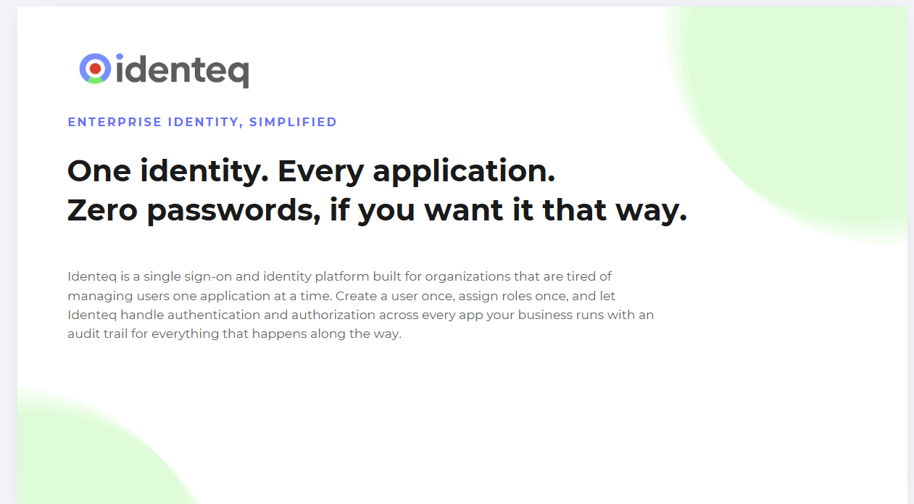
Identeq Presentation Deck: A 20-slide presentation deck was built from scratch for Identeq using Canva, with fully branded styling, communicating the platform's single sign-on and identity management features in a clear, structured format.

Figure 4.7: Identeq Sample Slide

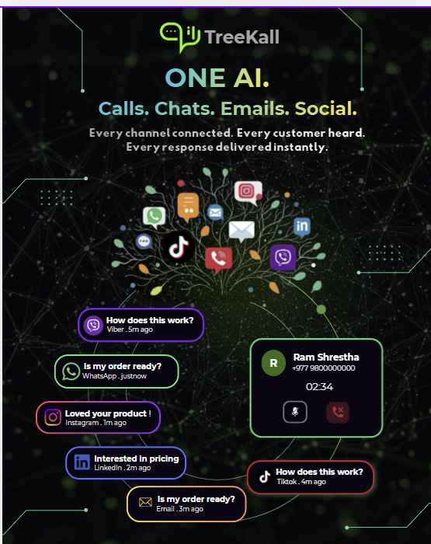
Instagram Post Assets: Editable Instagram post templates were developed using Canva, including quote posts, feature-grid layouts, and flow diagrams. Each post was built directly in Canva using its layout and text tools, styled to match brand colors and fonts, then structured as reusable templates that could be duplicated and edited quickly for future posts. Layouts were iterated multiple times based on feedback from the supervisor to improve visual appeal and brand consistency
Figure 4.8: Instagram Post Asset (Canva/PPTX)

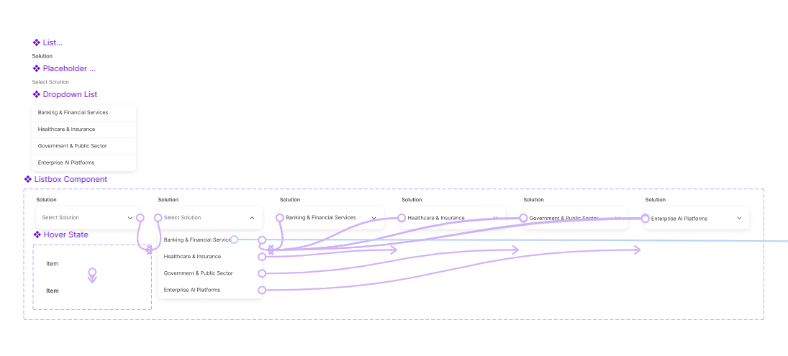
Figma Prototyping: Prototyping in Figma is the process of transforming static interface designs into interactive, navigable simulations that closely mimic the behavior of a finished application or website. At its core, it involves connecting individual design frames each representing a screen or state through defined interactions, allowing users to click, tap, or hover to trigger transitions between them. For the aimid website design file, this meant setting up "On Hover" triggers on navigation elements to open dropdown menus, using "Open Overlay" actions to simulate modal and panel interactions, and applying "Smart Animate" to create smooth, natural-feeling transitions when elements changed position or state. Component variants were also built for repeated UI elements such as buttons, navigation items, and cards so that different states (default, hover, active) could be swapped and tested consistently across the prototype without rebuilding each instance from scratch. Beyond demonstration, this prototyping work served as a vital tool for validating aimid's navigation flow, catching usability issues before development began, and giving the development team a clear, interactive specification to reference during implementation all within Figma's collaborative, non-coding environment that bridges the gap between design concepts and functional understanding.

Figure 4.9: Dropdown Interaction
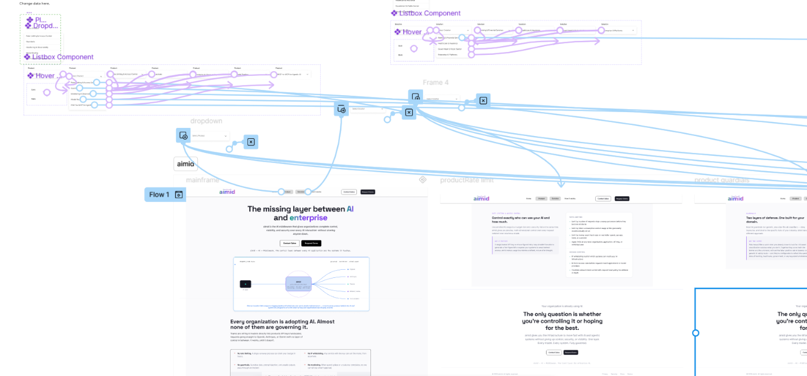
Figure 4.10: Prototyping
CHAPTER 5

CONCLUSION AND LEARNING OUTCOMES

5.1 Conclusion
In conclusion, the internship at Treeleaf Technologies provided a valuable and enriching learning experience that delivered practical exposure to UI/UX and presentation design in a professional, fast-moving AI company. During the internship, hands-on work was conducted across three product lines aimid, Identeq, and TreeKall where contributions included designing multi-slide presentations, an HTML landing page, social media assets, and interactive Figma prototypes.
By engaging with real project requirements and receiving iterative feedback from a supervisor, practical experience was gained in creating structured, visually consistent design deliverables that aligned with organizational branding and communication goals. Working across multiple products simultaneously also strengthened the ability to adapt design language and messaging to different audiences and product goals.
Additionally, the internship created opportunities to collaborate with a mentor and supervisor, clarifying how design work integrates into a company's broader product marketing and development workflow. Through regular reviews and iterative improvements, the importance of clarity, consistency, and responsiveness to feedback in professional design work was reinforced. Overall, the internship strengthened technical, creative, and problem-solving skills while providing real-world insight into how AI products are visually communicated and brought to market in a professional organizational environment.

5.2 Learning Outcome

UI/UX and Presentation Design Proficiency:
- Gained practical experience in core design processes, including presentation design, landing page design, and interactive prototyping.
- Applied user-centered design principles to create intuitive, accessible, and visually consistent presentations and interfaces.
- Designed branded PowerPoint decks, HTML landing pages, and social media assets using PowerPoint, Canva, and HTML/CSS.
- Developed a strong understanding of visual hierarchy, typography, color systems, spacing, and layout consistency across formats.

Practical Application of Design Knowledge:
- Translated product requirements into functional, visually engaging design solutions across three distinct AI products.
- Iteratively improved designs based on direct feedback from the supervisor, refining layouts, copy, and visual structure.
- Built interactive prototypes in Figma, including hover-triggered dropdowns and component variants, to support development handoff.

Professional and Personal Development:
- Improved communication skills through regular collaboration with the mentor and supervisor.
- Strengthened problem-solving and adaptability by designing across multiple products with different goals and audiences.
- Learned effective time management by balancing design tasks across aimid, Identeq, and TreeKall within project timelines.
- Gained exposure to real-world design workflows, brand consistency practices, and professional working standards at an AI company.

Overall Learning Outcome:
- Developed the ability to design clear, consistent, and visually engaging materials for technically complex AI products.
- Gained practical understanding of how design integrates into product marketing and development within a software company.
- Built a strong foundation for future roles in UI/UX design, presentation design, and product design.

REFERENCES
Kim, E., Beckman, S. L., & Agogino, A. M. (2022). User-centered design roadmapping: Anchoring roadmapping in customer value before technology selection. IEEE Transactions on Engineering Management, 69(1), 109–126. https://doi.org/10.1109/TEM.2020.3030172
Cajander, Å., Larusdottir, M., & Geiser, J. L. (2022). UX professionals' learning and usage of UX methods in agile. Information and Software Technology, 151, 107005. https://doi.org/10.1016/j.infsof.2022.107005
Muhyidin, M. A., Sulhan, M. A., & Sevtiana, A. (2020). UI/UX design for the My Chic application student academic information service using the Figma application. Jurnal Digit, 10(2), 208–219.
Mäntymäki, M., Ahokangas, P., & Oksanen, A. (2022). Defining organizational AI governance. AI and Ethics, 2, 603–609. https://doi.org/10.1007/s43681-022-00143
National Institute of Standards and Technology. (2023). AI risk management framework 1.0 (NIST AI 100-1). U.S. Department of Commerce. https://doi.org/10.6028/NIST.AI.100-1

APPENDICES
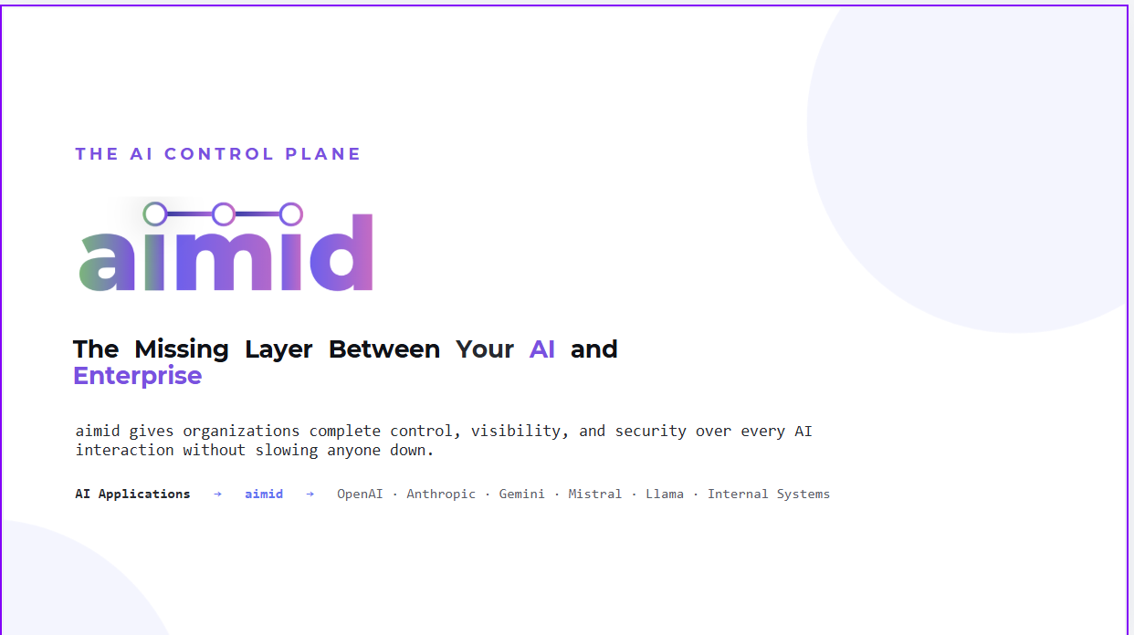 aimid Presentation
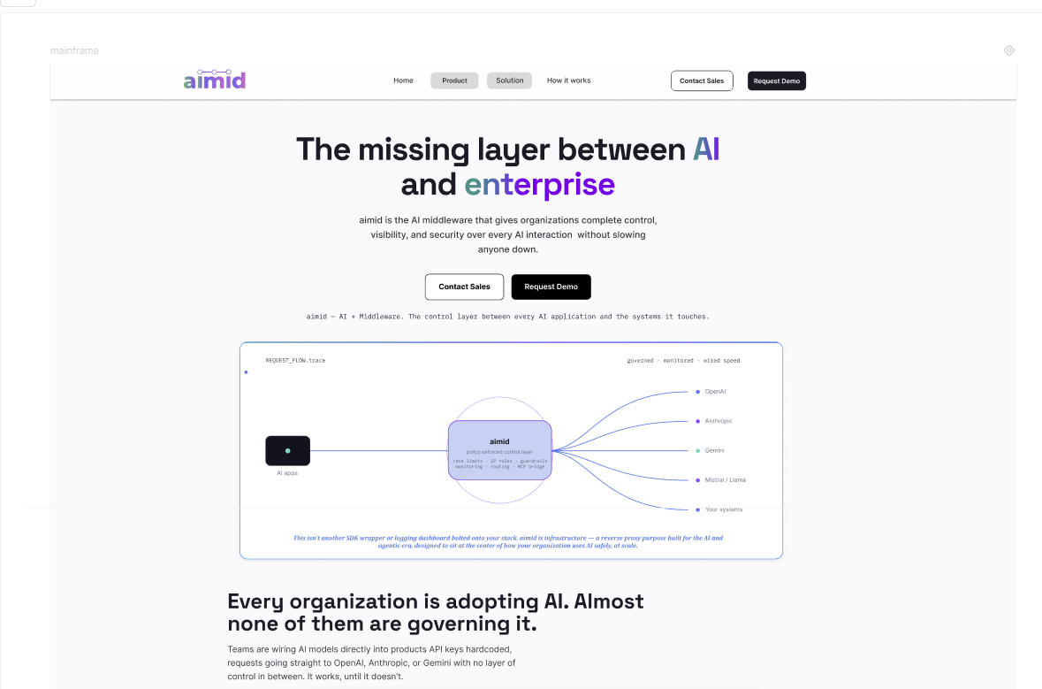
aimid Landing Page
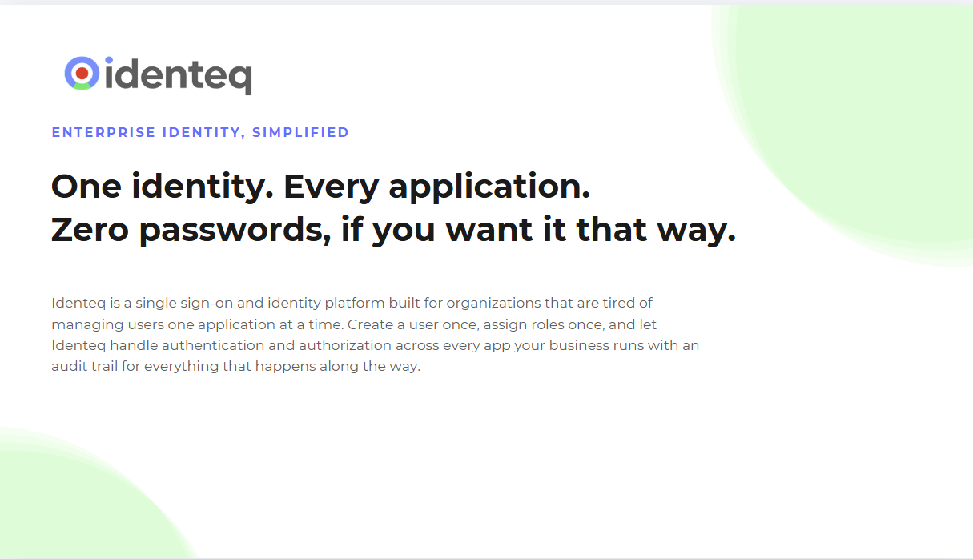
Identeq Presentation
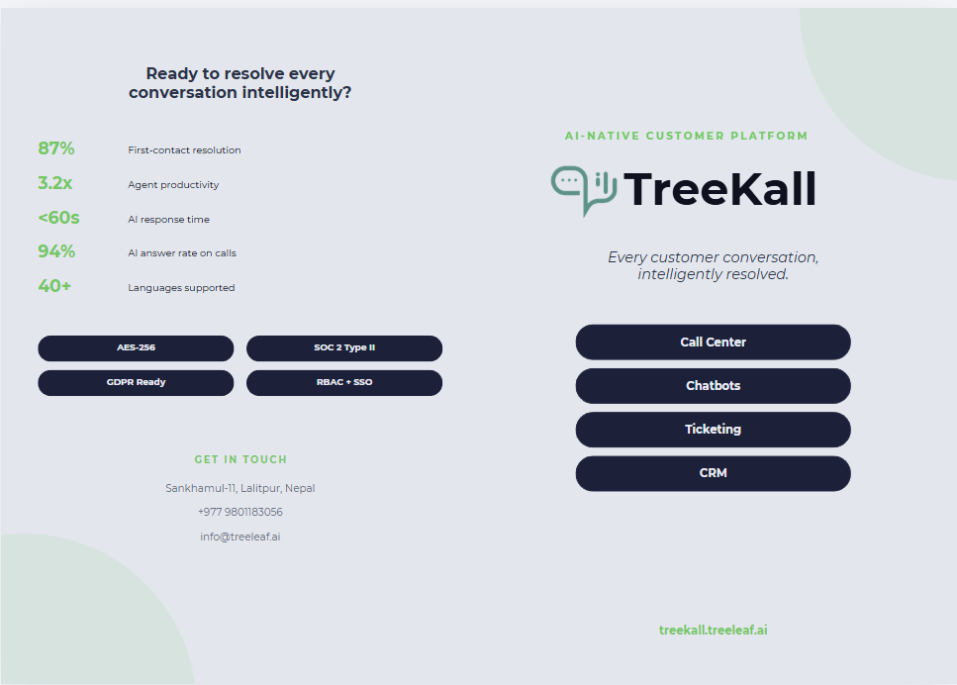
TreeKall Brochure

